TEAM4OIES

Web Site Design

Version 2.0

Signature Block

COSC 4351 | Name Signature | Date
SE Team Leader
SQA
SQA
Content Outline
Master Page / wireframe
- Links
  - Doesn’t change and controls the home page view
  - Links will include:
    - Home
    - Testimonials
    - About Us
    - Contact Us
- Log in
  - When you first enter it will display as a log in with username and password
  - After signing in will display some links for account info
- Chat box
  - Its own section.
  - Contains the chat box window. One chat for whole site.
  - This could be upgraded later for better support options.
- Home Page
  - Center of Page
  - This is what changes when different links are pressed.
  - Home:
    - Stating page
    - General information
  - Testimonials
  - About Us
  - Contact Us
TEAM4OIES
Links
Home Page

Search
Footer

Photo
news
Snag line statement
TEAM4OIES
Links
Search
Footer
About Us
Position
img
Position
Position
Mission Statement

1
TEAM4OIES
Links
Search
Footer

2
Contact Us

Comment Submission
Form
Address,
Phone number
Other information
3
TEAM4OIES
Links
Search
Footer

Testimonial 1
Testimonial 2
Testimonial 3
Testimonial 4
Search

Testimonial

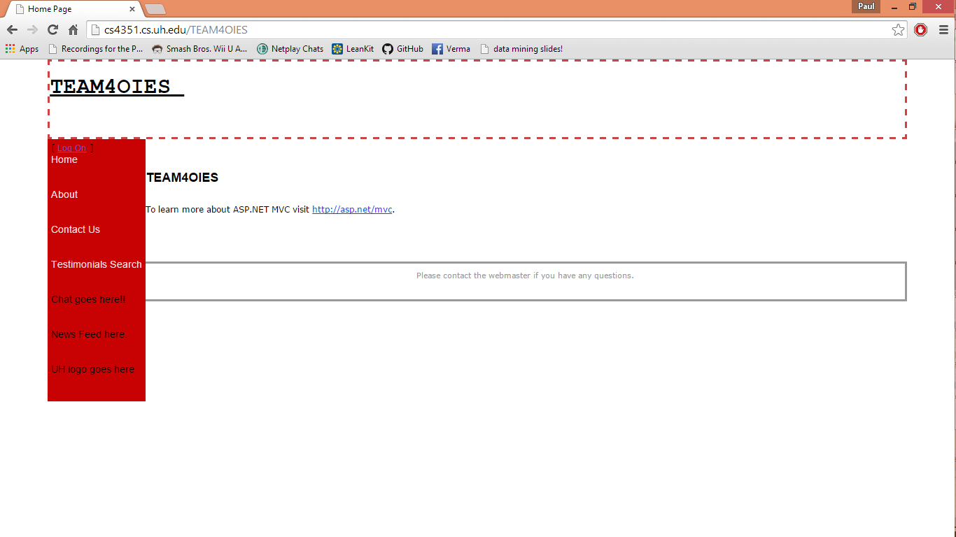
Document Control

Change History

Table 1: TLs entries (assigned work and due dates) before releasing to the team (all SQAs)
Revision | Name | Due Date | Description
1.A | TM Janaye Maggart | 03/06/2015 | Complete XXX
1.B | TM Sarah Moore | 03/06/2015 | Complete YYY
1.C | DBA Logan Stark | 03/06/2015 | Complete ZZZ
1.X | SQA Linh Tong | 03/07/2015 | Review Document
1.Y | SQA Paul Miller | 03/08/2015 | Review Document

Table 2: Entries when work completed (SVN Commit Comment matches Description)
Revision | Name | Completed Date | Description
1.A | TM Janaye Maggart | 03/07/2015 | I aided in planning the rough draft of the website design
1.B | TM Sarah Moore | 02/26/2015 | I completed the rough draft of the website design
1.C | DBA Logan Stark | 03/06/2015 | I completed the content outline and rendition of master page wireframe
1.X | SQA Linh Tong | 03/07/2015 | I reviewed Document
1.Y | SQA Paul Miller | 03/08/2015 | I reviewed Document

Table 3: TL entry for RED DELIVERABLES (SVN Commit Comment matches Description)
Revision | Name | Due Date | Description
2.0 | TL Javier Rivera | 03/08/2015 | I changed Version to 2.0

Document Storage
This file is stored in SVN at https://svn.cs.u.edu/svn/cosc4351/team4/TEAM PROJECT DELIVERABLES/Web Site Design.doc.

